BANK LOAN REPORT QUERY DOCUMENT
- BANK LOAN REPORT |SUMMARY
KPI’s:
Total Loan Applictions:
SELECT COUNT (id) AS Total_Loan_Applictions FROM Bank_loan_data
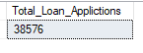
MTD Loan Applications:
SELECT COUNT(id) AS MTD_Total_Loan_Applictions FROM Bank_loan_data
WHERE MONTH(issue_date) = 12 AND YEAR(issue_date) = 2021
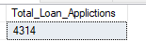
PMTD Loan Applications:
SELECT COUNT(id) AS PMTD_Total_Loan_Applictions FROM Bank_loan_data
WHERE MONTH(issue_date) = 11 AND YEAR(issue_date) = 2021
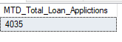
Total Funded Amount :
SELECT SUM(loan_amount) AS Total_Funded_Amount FROM Bank_loan_data
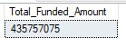

MTD Total Funded Amount :
SELECT SUM(loan_amount) AS MTD_Total_Funded_Amount FROM Bank_loan_data
WHERE MONTH(issue_date) = 12 AND YEAR(issue_date) = 2021
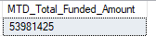
PMTD Total Funded Amount :
SELECT SUM(loan_amount) AS PMTD_Total_Funded_Amount FROM Bank_loan_data
WHERE MONTH(issue_date) = 11 AND YEAR(issue_date) = 2021
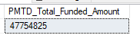
Total Amount Received:
SELECT SUM(total_payment) AS Total_Amount_Received FROM Bank_loan_data
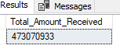

MTD Total Amount Received:
SELECT SUM(total_payment) AS MTD_Total_Amount_Received FROM Bank_loan_data
WHERE MONTH(issue_date) = 12 AND YEAR(issue_date) = 2021
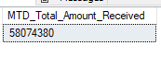
PMTD Total Amount Received:
SELECT SUM(total_payment) AS PMTD_Total_Amount_Received FROM Bank_loan_data
WHERE MONTH(issue_date) = 11 AND YEAR(issue_date) = 2021
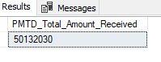
Average Interest Rate:
SELECT ROUND(AVG(int_rate),5)*100 AS Avg_Interest_Rate FROM Bank_loan_data
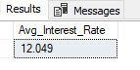

MTD Average Interest Rate:
SELECT ROUND(AVG(int_rate),5)*100 AS MTD_Avg_Interest_Rate FROM Bank_loan_data
WHERE MONTH(issue_date) = 12 AND YEAR(issue_date) = 2021
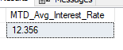

PMTD Average Interest Rate:
SELECT ROUND(AVG(int_rate),5)*100 AS PMTD_Avg_Interest_Rate FROM Bank_loan_data
WHERE MONTH(issue_date) = 11 AND YEAR(issue_date) = 2021
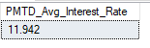

Avg DTI:
SELECT AVG(dti)*100 AS Avg_DTI FROM Bank_loan_data
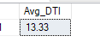

MTD Avg DTI:
SELECT ROUND(AVG(dti),4)*100 AS MTD_Avg_DTI FROM Bank_loan_data
WHERE MONTH(issue_date) = 12 AND YEAR(issue_date) = 2021
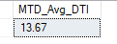

PMTD Avg DTI:
SELECT ROUND(AVG(dti),4)*100 AS PMTD_Avg_DTI FROM Bank_loan_data
WHERE MONTH(issue_date) = 11 AND YEAR(issue_date) = 2021
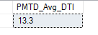

GOOD LOAN ISSUED:
Good Loan Percentage :
SELECT (COUNT (CASE
WHEN loan_status = 'Fully Paid' OR loan_status = 'Current'
THEN id END)*100) / COUNT(id) AS Good_Loan_Percentage
From Bank_loan_data
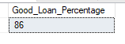
Good Loan Applications
SELECT COUNT(id) AS Good_Loan_Applications FROM Bank_loan_data
WHERE loan_status = 'Fully Paid' OR loan_status = 'Current'
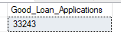
Good Loan Funded Amount
SELECT SUM(loan_amount) AS Good_Loan_Funded_Amount FROM Bank_loan_data WHERE loan_status IN ('Fully Paid' , 'Current')
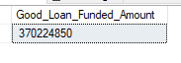
Good Loan Amount Received
SELECT SUM(total_payment) AS Good_Loan_Amount_Received FROM Bank_loan_data WHERE loan_status IN ('Fully Paid' , 'Current')
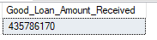

BAD LOAN ISSUED:
Bad Loan Percentage
SELECT (COUNT(CASE
WHEN loan_status = 'Charged off' THEN id END)*100.0)/
COUNT(id) AS Bad_Loan_Percentage FROM Bank_loan_data
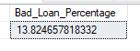
Bad Loan Applications
SELECT COUNT(id) AS Bad_Loan_Applictions FROM Bank_loan_data
WHERE loan_status = 'Charged Off'
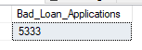
Bad Loan Funded Amount
SELECT SUM(loan_amount) AS Bad_Loan_Funded_amount
FROM bank_loan_data WHERE loan_status = 'Charged Off'

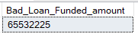

Bad Loan Amount Received
SELECT SUM(total_payment) AS Bad_Loan_amount_received FROM bank_loan_data
WHERE loan_status = 'Charged Off'
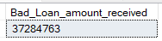

LOAN STATUS
SELECT
loan_status,
COUNT(id) AS Total_Loan_Applications,
SUM(total_payment) AS Total_Amount_Received,
SUM(loan_amount) AS Total_Funded_Amount,
AVG(int_rate * 100) AS Interest_Rate,
AVG(dti * 100) AS DTI
FROM
Bank_loan_data
GROUP BY
loan_status
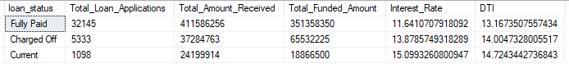

MTD_Total_Amount_Received & MTD_Total_Funded_Amount
SELECT
loan_status,
SUM(total_payment) AS MTD_Total_Amount_Received,
SUM(loan_amount) AS MTD_Total_Funded_Amount
FROM Bank_loan_data
WHERE MONTH(issue_date) = 12
GROUP BY loan_status
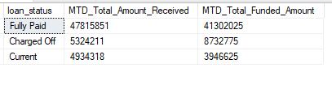

- BANK LOAN REPORT | OVERVIEW
Monthly Trend :
SELECT
MONTH(issue_date) AS Month_Munber,
DATENAME(MONTH, issue_date) AS Month_name,
COUNT(id) AS Total_Loan_Applications,
SUM(loan_amount) AS Total_Funded_Amount,
SUM(total_payment) AS Total_Amount_Received
FROM Bank_loan_data
GROUP BY MONTH(issue_date), DATENAME(MONTH, issue_date)
ORDER BY MONTH(issue_date)
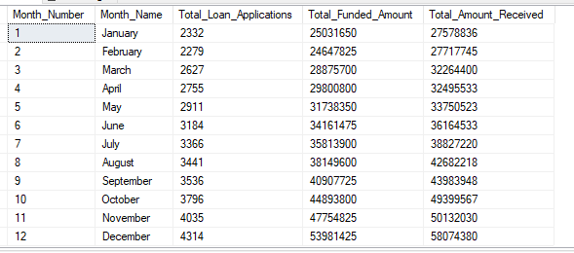

STATE
SELECT
address_state AS State,
COUNT(id) AS Total_Loan_Applications,
SUM(loan_amount) AS Total_Funded_Amount,
SUM(total_payment) AS Total_Amount_Received
FROM Bank_loan_data
GROUP BY address_state
ORDER BY address_state
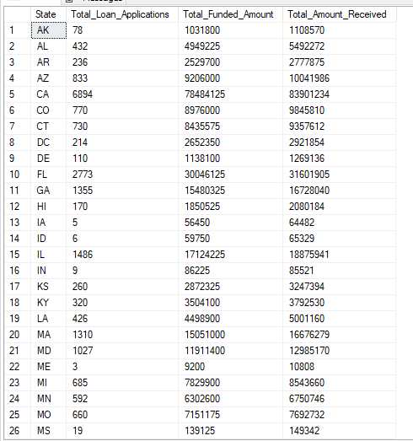

TERM
SELECT
term AS Term,
COUNT(id) AS Total_Loan_Applications,
SUM(loan_amount) AS Total_Funded_Amount,
SUM(total_payment) AS Total_Amount_Received
FROM Bank_loan_data
GROUP BY term
ORDER BY term

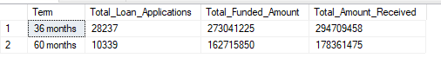
EMPLOYEE LENGTH
SELECT
emp_length AS Employee_Length,
COUNT(id) AS Total_Loan_Applications,
SUM(loan_amount) AS Total_Funded_Amount,
SUM(total_payment) AS Total_Amount_Received
FROM Bank_loan_data
GROUP BY emp_length
ORDER BY emp_length
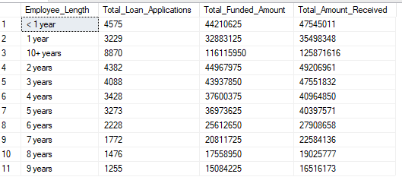

PURPOSE
SELECT purpose AS PURPOSE,
COUNT(id) AS Total_Loan_Applications,
SUM(loan_amount) AS Total_Funded_Amount,
SUM(total_payment) AS Total_Amount_Received
FROM bank_loan_data
GROUP BY purpose ORDER BY purpose

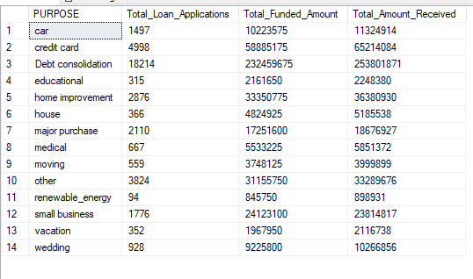
HOME OWNERSHIP
SELECT home_ownership AS Home_Ownership,
COUNT(id) AS Total_Loan_Applications,
SUM(loan_amount) AS Total_Funded_Amount,
SUM(total_payment) AS Total_Amount_Received
FROM bank_loan_data GROUP BY home_ownership
ORDER BY home_ownership

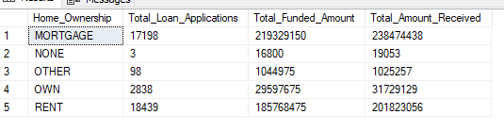

Note: I have applied multiple Filters on all the dashboards. You can check the results for the filters as well by modifying the query and comparing the results.
For e.g
See the results when we hit the Grade A in the filters for dashboards.
SELECT
purpose AS PURPOSE,
COUNT(id) AS Total_Loan_Applications,
SUM(loan_amount) AS Total_Funded_Amount,
SUM(total_payment) AS Total_Amount_Received
FROM bank_loan_data
WHERE grade = 'A'
GROUP BY purpose
ORDER BY purpose
